We use data structure like object array, array List, hashmap to write data in excel.

To write data in excel the Order should be - workbook-->sheet-->row-->cell.

1. Create blank workbook-

XSSFWorkbook workbook = **new** XSSFWorkbook();

1. Using workbook Object reference – create sheet.

XSSFSheet sheet = workbook.createSheet("EmpInfo");

1. so to hold the data in sheet we will use data structure like – Object array, ArrayList, HashMa and then we finally store the data from sheet to excel. We are using 2D Object array which will hold all type of data.

Object empdata[][]= { {"EmpID","Name","Job"},

{"101","Sneha","Tester"},

{"102","Anvi","Devloper"},

{"103","Nidhi","Manager"},

};

1. find out no. of rows and cols -
2. Count no. of rows from 2D array -

**int** rows = empdata.length;

1. Count no. of cols from 2D array - To get no. of cols from 2D array - mentioned row no. to get cols length.

**int** cols = empdata[0].length;

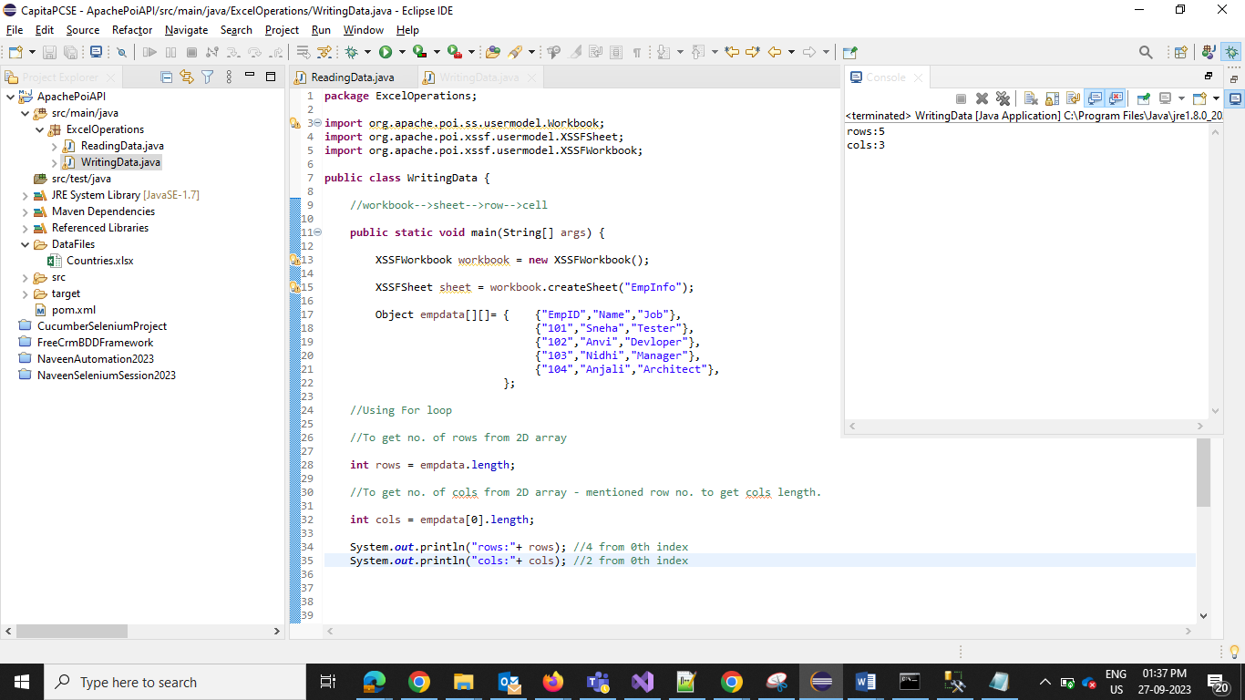

1. Now Write data in Sheet – using for loop
2. External for loop – represent rows. Create new row using method –

**for**(**int** r=0;r<rows;r++)

{

XSSFRow row = sheet.createRow(r);

}

1. Internal for loop – represent cols/cells. Create new cells using row obj reference from external loop. Cells will be created in that row.

**for**(**int** r=0;r<rows;r++)

{

XSSFRow row = sheet.createRow(r);

**for**(**int** c=0;c<cols;c++)

{

XSSFCell col=row.createCell(c);

}

}

C. once we create the rows and cell, we have to read the data from 2d array and write it into excel.

Object excelValues = empdata[r][c];

**for**(**int** r=0;r<rows;r++)

{

XSSFRow row = sheet.createRow(r);

**for**(**int** c=0;c<cols;c++)

{

XSSFCell col=row.createCell(c);

Object excelValues = empdata[r][c];

}

}

1. Before writing the data in cell, identify the type of data

**instanceof** – this method will identity the type of data.

setCellValue – this method will set the value in cell after identifying type of data.

**if**(excelValues **instanceof** String)

cell.setCellValue((String) excelValues);

**if**(excelValues **instanceof** Integer)

cell.setCellValue((Integer)excelValues);

**if** (excelValues **instanceof** Boolean)

cell.setCellValue((**boolean**)excelValues);

1. Write the workbook in file system.
2. Specify the file path – String FilePath = ".\\DataFiles\\Employee.xlsx";
3. Open the file in output stream and pass the file path –

FileOutputStream outstream = **new** FileOutputStream(FilePath);

1. write the workbook into file system

workbook.write(outstream);

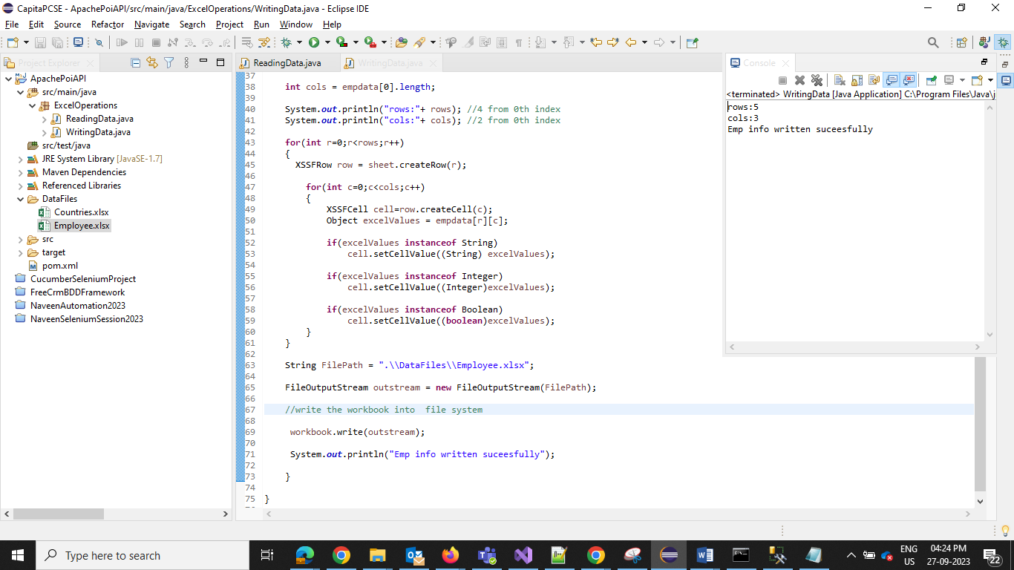

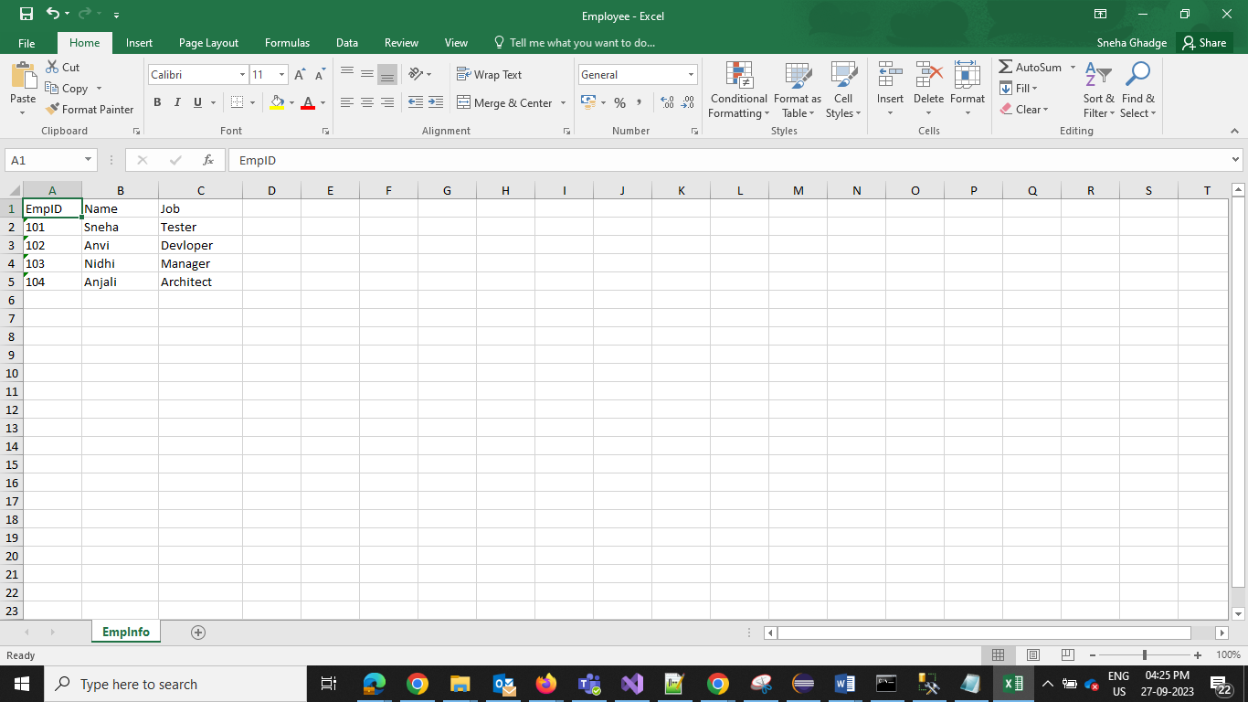

Using for… each loop –

1. for each loop – set rowCount=0
2. read data from 2D array – emp is single dimensional object array which will hold 1st row from 2D empdata array- **for**(Object value:emp)
3. now we have write data from emp into excel rows. create row and increase the row countand stored it in row type var.

XSSFRow row = sheet.createRow(rowCount++);

1. inner for loop – which will create cells. Cell count=0.

Take emp (which is single dimensional object array and contains 1st row data)and update the 1st cell with data. And increase the cell count. Store in cell type var.

XSSFCell cell = row.createCell(colCount++);

1. once we get the value check the data type and then set the value in cell.

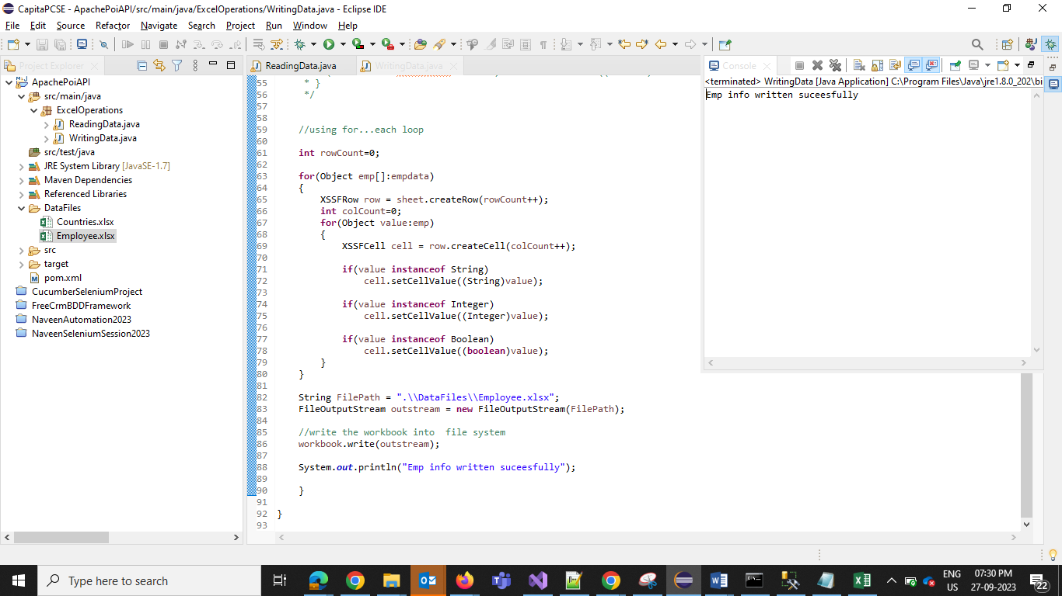

/

//Storing data in ArrayList- which is of type Object Array.

//every object is single dimensional array which contains multiple values.

